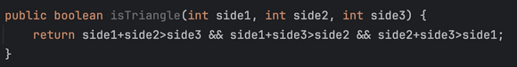

Клаузули:

a: side1+side2>side3  
b: side1+side3>side2  
c: side2+side3>side1  
  
Предикат:

P: a && b && c

|  |  |  |  |  |  |  |  |
| --- | --- | --- | --- | --- | --- | --- | --- |
|  | a | b | c | P | Pa | Pb | Pc |
| 1 | T | T | T | T | ✔ | ✔ | ✔ |
| 2 | T | T | F | F |  |  | ✔ |
| 3 | T | F | T | F |  | ✔ |  |
| 4 | T | F | F | F |  |  |  |
| 5 | F | T | T | F | ✔ |  |  |
| 6 | F | T | F | F |  |  |  |
| 7 | F | F | T | F |  |  |  |
| 8 | F | F | F | F |  |  |  |

GACC:

|  |  |
| --- | --- |
| Major Clause | Set of possible tests |
| a | (1,5) |
| b | (1,3) |
| c | (1,2) |

RACC:

|  |  |
| --- | --- |
| Major Clause | Set of possible tests |
| a | (1,5) |
| b | (1,3) |
| c | (1,2) |

За двете покривања се добива исто, па ќе се добијат и исти тестови:  
1,2,3,5